9.26 8th Main question

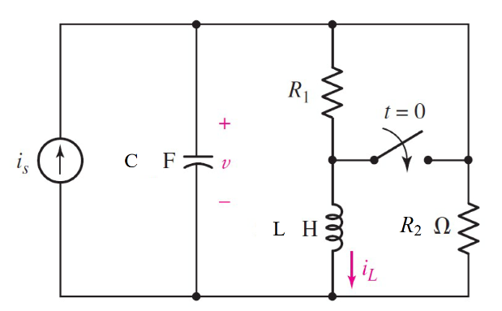

Given is = 30 *u(-t) mA*, r1= ?, r2= 5 Ω, c = 200 µF, l= 20 mH, vc0=6 v

Find Critical damping

Variables

Random variables

#l < 4*r*r*c Parallel, c < 4*r*r/l Series

is = {0.01:0.05:0.01};

vc0 = {5:10:1};

r2 = {1:5:1};

c = {50e-6:200e-5:50e-5};

l = {0.01:0.05:0.01};

Global variables

#is = 0.03; r2 = 5; c = 200e-6;

l = 20e-3; vc0=6;time = 0.001;

# t = 0-

r=is/((r2*is) – vc0);

r1=abs(r);

il0 = (r2/(r1+r2))/is;

# t = 0+

rth = r2;

alpha = 1/(2*rth*c);

w0 = alpha;

ir = vc0/r2;

ico = -il0-ir;

A2 = vc0;

A1 = ic/c + alpha*A2;

vct = (A1*time+A2)exp(alpha*time);

Part (กรอกคำตอบ)

1. *R1* = r1 = 5.13 Ω
2. *iL*(0+) = il0 = 14.8 mA
3. *α* = alpha = 500 s^-1
4. *ω*0 = w0 = 500 rad/s

At *t* > 0

1. *vc*(*t*) = (A1*t+A2)exp(-alpha*t)

= (-3074*t+6)exp(-500*t)

1. 6. *vc*(time*τ*) = vct = 13.974 V

9.28 8th Main question

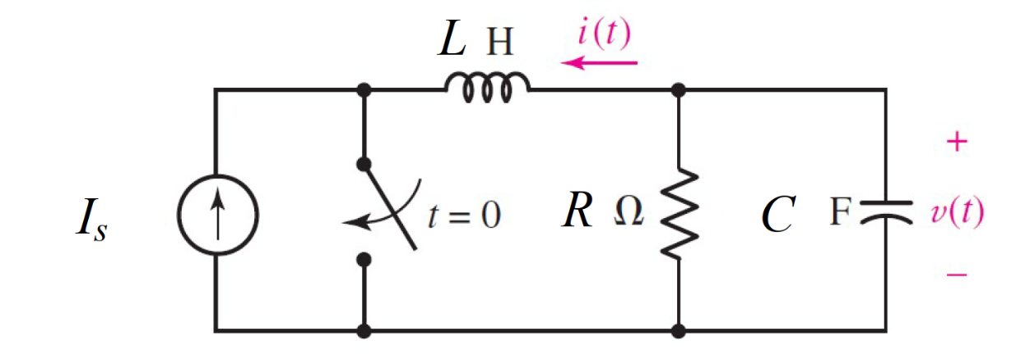

Given Is = 310 *mA*, r= 14 Ω, c = 360 µF,

Find

Variables

Random variables

#l < 4*r*r*c Parallel, c < 4*r*r/l Series

is = {0.31:0.40:0.01};

r = {10:20};

c = {300e-6:400e-6:20e-6};

Global variables

#is = 310 e-3; r = 14; c = 0.36e-3;

time = 0.01;

# t = 0-

l=4*r*r*c;

il0 = -is;

vc0 = is*r;

# t = 0+

rth = r2;

alpha = 1/(2*rth*c);

w0 = alpha;

ir = vc0/r

ico = -il0-ir;

A2 = vc0;

A1 = ic/c + alpha*A2;

vct = (A1*time+A2)exp(alpha*time);

Part (กรอกคำตอบ)

1. *L* = l = 0.282 H
2. *iL*(0-) = il0 = -310 mA
3. *vc*(0-) = vc0 = 4.34 V
4. *α* = alpha = 99.2 s^-1
5. *ω*0 = w0 = 99.2 rad/s

At *t* > 0

1. *vc*(*t*) = (A1*t+A2)exp(-alpha*t)

= (430.57*t+4.34)exp(-99.21*t)V

1. *vc*(time*τ*) = vct = 3.205 V

9.27 7th Main question

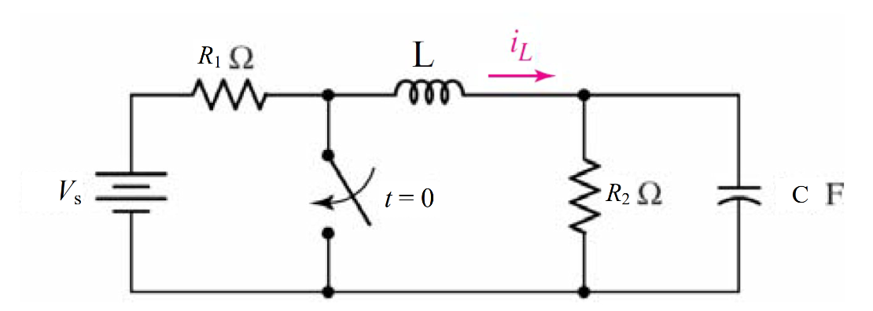

Given vs = 12 *V*, r1= 5 Ω, r2= 1 Ω, c = 2 mF,

Find

Variables

Random variables

#l < 4*r*r*c Parallel, c < 4*r*r/l Series

vs = {10:20};

r1 = {1:10};

r2 = {1:10};

c = {1e-3:6e-3:1e-3};

Global variables

#vs = 12; r1 = 5;r2=1; c = 2e-3;

time = 0.01;

# t = 0-

l=4*r*r*c;

il0 = vs/(r1+r2);

vc0 = ilo*r2;

# t = 0+

rth = r2;

alpha = 1/(2*rth*c);

w0 = alpha;

vl0= -vc0;

ir = vc0/r

ico = -il0-ir;

A2 = il0;

A1 = vl0/l + alpha*A2;

ilt = (A1*time+A2)exp(alpha*time);

Part (กรอกคำตอบ)

1. *L* = l = 8 mH
2. *iL*(0-) = il0 = 2 A
3. *vc*(0-) = vc0 = 2 V
4. *α* = alpha = 250 s^-1
5. *ω*0 = w0 = 250 rad/s

At *t* > 0

*iL*(*t*) = (A1*t+A2)exp(-alpha*t)

= (250*t+2)exp(-250*t)V

6. *iL*(time*τ*) = ilt = 0.369 V

9.28 7th Main question

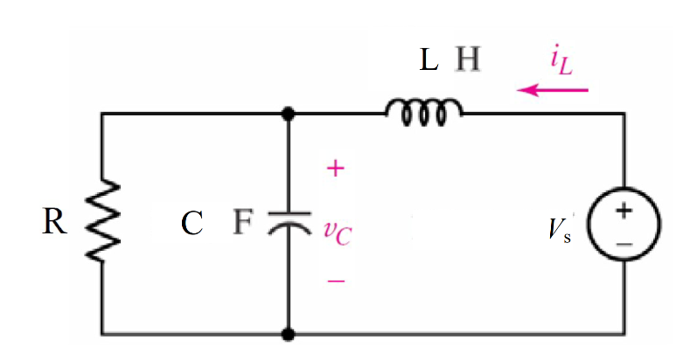

Given vs = 100 *u(-t) V*, c = 2.5 µF, l= 100/3 mH

Find Critical damping

Variables

Random variables

#l < 4*r*r*c Parallel, c < 4*r*r/l Series

vs = {1:10};

r1 = {10000:30000:1000};

c = {1e-3:5e-3:0.5e-3};

l = {100/3:200/3:10/3};

Global variables

#vs = 100; c = 2.5e-6;

l = (100/3)*e-3;time = 0.001;

# t = 0-

r=sqrt(l/4*c);

il0 = vs/r;

vc0=vs;

# t = 0+

rth = r;

alpha = 1/(2*rth*c);

w0 = alpha;

ir = vc0/r;

ico = il0-ir;

A2 = vc0;

A1 = ic/c + alpha*A2;

vct = (A1*time+A2)exp(alpha*time);

Part (กรอกคำตอบ)

1. *R1* = r = 57.74 Ω

2. *iL*(0+) = il0 = 1.732A

3. *α* = alpha = 3464 s^-1

4. *ω*0 = w0 = 3464 rad/s

At *t* > 0

5. *vc*(*t*) = (A1*t+A2)exp(-alpha*t)

= (346400*t+100)exp(-3464*t)

6. *vc*(time*τ*) = vct = 13.974 V